Name=Rushang Bagada
Rollno=U24CS076
// write C++ programs that illustrate how the following forms of inheritance are supported:

#include<bits/stdc++.h>
using namespace std;

// a)Single inheritance
class A {
public:
int a;
};

class B : public A {
public:
int b;
};

// b)Multiple inheritance
class C {
public:
int c;
};

class D : public A, public C {
public:
int d;
};

// c)Multilevel inheritance
class E : public B {
public:
int e;
};

// d)Hierarchical inheritance
class F : public A {
public:
int f;
};

class G : public A {
public:
int g;
};

int main() {
// Single inheritance
B objB;
objB.a = 10;
objB.b = 20;
cout << "a: " << objB.a << ", b: " << objB.b << endl;

// Multiple inheritance
D objD;
objD.a = 10;
objD.c = 30;
objD.d = 40;
cout << "a: " << objD.a << ", c: " << objD.c << ", d: " << objD.d << endl;

// Multilevel inheritance
E objE;
objE.a = 10;
objE.b = 20;
objE.e = 50;
cout << "a: " << objE.a << ", b: " << objE.b << ", e: " << objE.e << endl;

// Hierarchical inheritance
F objF;
G objG;
objF.a = 10;
objF.f = 60;
objG.a = 10;
objG.g = 70;
cout << "a: " << objF.a << ", f: " << objF.f << endl;
cout << "a: " << objG.a << ", g: " << objG.g << endl;

return 0;
}
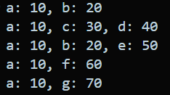
// To develop an application with Employee class with Emp_name, Emp_id, Address, Mail_id,
// Mobile_no as members. Inherit the classes, Programmer, Assistant Professor, Associate
// Professor and Professor from employee class. Add Basic Pay (BP) as the member of all the
// inherited classes with 97% of BP as DA, 10 % of BP as HRA, 12% of BP as PF, 0.1% of
// BP for staff club fund. Generate pay slips for the employees with their gross and net salary

#include <iostream>
#include <string>
using namespace std;

class Employee {
protected:
string Emp_name, Emp_id, Address, Mail_id;
long long Mobile_no;

public:
void getDetails() {
cout << "Enter Employee Name: ";
cin >> Emp_name;
cout << "Enter Employee ID: ";
cin >> Emp_id;
cout << "Enter Address: ";
cin.ignore();
getline(cin, Address);
cout << "Enter Mail ID: ";
cin >> Mail_id;
cout << "Enter Mobile No: ";
cin >> Mobile_no;
}

void displayDetails() {
cout << "\nEmployee Details:" << endl;
cout << "Name : " << Emp_name << endl;
cout << "ID : " << Emp_id << endl;
cout << "Address : " << Address << endl;
cout << "Mail ID : " << Mail_id << endl;
cout << "Mobile No : " << Mobile_no << endl;
}
};

class PaySlip : public Employee {
protected:
float BP, DA, HRA, PF, StaffClub, Gross, Net;
public:
void getPay() {
cout << "Enter Basic Pay (BP): ";
cin >> BP;

DA = 0.97 * BP;
HRA = 0.10 * BP;
PF = 0.12 * BP;
StaffClub = 0.001 * BP;

Gross = BP + DA + HRA;
Net = Gross - (PF + StaffClub);
}

void generatePaySlip() {
displayDetails();
cout << "\n------ Pay Slip ------" << endl;
cout << "Basic Pay: " << BP << endl;
cout << "DA (97%): " << DA << endl;
cout << "HRA (10%): " << HRA << endl;
cout << "PF (12%): " << PF << endl;
cout << "Staff Club (0.1%): " << StaffClub << endl;
cout << "Gross Salary: " << Gross << endl;
cout << "Net Salary: " << Net << endl;
}
};

class Programmer : public PaySlip {};
class AssistantProfessor : public PaySlip {};
class AssociateProfessor : public PaySlip {};
class Professor : public PaySlip {};

int main() {
int choice;
cout << "Select Employee Type:\n";
cout << "1. Programmer\n2. Assistant Professor\n3. Associate Professor\n4. Professor\n";
cout << "Enter choice: ";
cin >> choice;

switch(choice) {
case 1: {
Programmer p;
p.getDetails();
p.getPay();
p.generatePaySlip();
break;
}
case 2: {
AssistantProfessor ap;
ap.getDetails();
ap.getPay();
ap.generatePaySlip();
break;
}
case 3: {
AssociateProfessor asp;
asp.getDetails();
asp.getPay();
asp.generatePaySlip();
break;
}
case 4: {
Professor prof;
prof.getDetails();
prof.getPay();
prof.generatePaySlip();
break;
}
default:
cout << "Invalid choice!" << endl;
}

return 0;
}

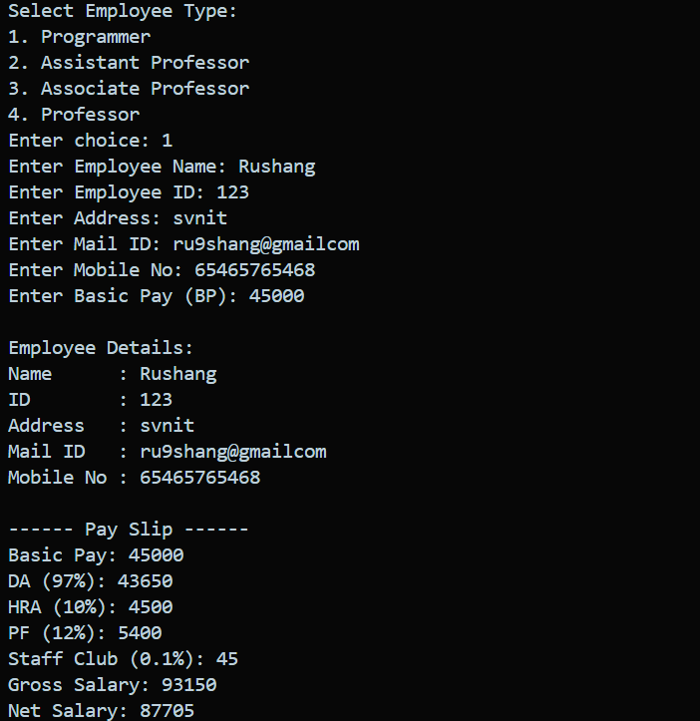

// Write a program with the base class PLUSData has two protected member variables namely
// N1 and N2. Class Addition is derived from the base class AddData by using simple
// inheritance

#include <bits/stdc++.h>
using namespace std;

class PLUSdata{
protected:
int N1;
int N2;
public:
void setData(int a,int b){
N1=a;
N2=b;
}
void getData(){
cout<<"The value of N1 is "<<N1<<endl;
cout<<"The value of N2 is "<<N2<<endl;
}
};

class addition:public PLUSdata{
public:
void Display(){
int sum=N1+N2;
cout<<"The sum of N1 and N2 is "<<sum<<endl;

}
};

int main(){
addition obj;
int a,b;
cout<<"Enter the value of N1 and N2"<<endl;
cin>>a>>b;
obj.setData(a,b);
obj.getData();
obj.Display();
return 0;
}
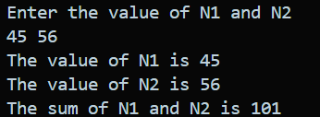

// Write a menu-driven C++ program that performs various string manipulation operations using the
// std::string class. The program should display a menu to the user with options to perform the
// following operations:
// Students have to enter their full name.
// Firstname_Middlename_Surname (First letter should be capital in each word)
// ● Input and Display a String
// ● Find the Length of a String
// ● Convert a String to Uppercase
// ● Reverse a String
// ● Search for a Substring
// ● Replace a Word in a String
// ● Exit the Program

#include <bits/stdc++.h>
using namespace std;

string capitalizeWords(string str) {
bool cap = true;
for (int i = 0; i < str.size(); i++) {
if (isspace(str[i])) {
cap = true; // Next character should be capital
} else if (cap && isalpha(str[i])) {
str[i] = toupper(str[i]);
cap = false;
} else {
str[i] = tolower(str[i]);
}
}
return str;
}

int main() {
string str;
int choice;

cout << "Enter your full name (Firstname Middlename Surname): ";
getline(cin, str);

// Capitalize the name properly
str = capitalizeWords(str);

while (true) {
cout << "\nMenu:\n";
cout << "1. Input and Display a String\n";
cout << "2. Find the Length of a String\n";
cout << "3. Convert a String to Uppercase\n";
cout << "4. Reverse a String\n";
cout << "5. Search for a Substring\n";
cout << "6. Replace a Word in a String\n";
cout << "7. Exit the Program\n";
cout << "Enter your choice: ";
cin >> choice;
cin.ignore(); // Clear newline

switch (choice) {
case 1:
cout << "String: " << str << endl;
break;

case 2:
cout << "Length of the string: " << str.length() << endl;
break;

case 3: {
string upper_str = str;
transform(upper_str.begin(), upper_str.end(), upper_str.begin(), ::toupper);
cout << "Uppercase String: " << upper_str << endl;
break;
}

case 4: {
string rev_str = str;
reverse(rev_str.begin(), rev_str.end());
cout << "Reversed String: " << rev_str << endl;
break;
}

case 5: {
string substr;
cout << "Enter the substring to search: ";
getline(cin, substr);
if (str.find(substr) != string::npos) {
cout << "Substring found!" << endl;
} else {
cout << "Substring not found!" << endl;
}
break;
}

case 6: {
string old_word, new_word;
cout << "Enter the word to replace: ";
getline(cin, old_word);
cout << "Enter the new word: ";
getline(cin, new_word);

size_t pos = str.find(old_word);
if (pos != string::npos) {
str.replace(pos, old_word.length(), new_word);
cout << "Updated String: " << str << endl;
} else {
cout << "Word not found!" << endl;
}
break;
}

case 7:
cout << "Exiting the program." << endl;
return 0;

default:
cout << "Invalid choice! Please try again." << endl;
}
}

return 0;
}

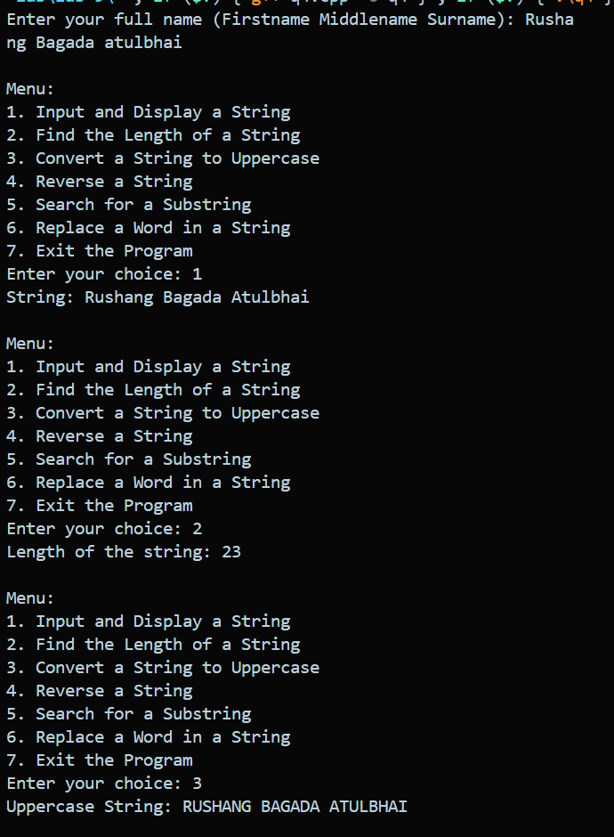

// Write a menu driven c + + program to perform the following operations:
// a) Whether the entered email address by user is valid or not. Print the message accordingly.
// b) Extract the domain name from the entered email address. And print the output

#include <bits/stdc++.h>
using namespace std;

bool isValidEmail(const string& email) {
const regex pattern(R"((^[a-zA-Z0-9._%+-]+@[a-zA-Z0-9.-]+\.[a-zA-Z]{2,}$))");
return regex_match(email, pattern);
}

int main() {
string email;
cout << "Enter an email address: ";
getline(cin, email);

if (isValidEmail(email)) {
cout << "The email address is valid." << endl;
} else {
cout << "The email address is invalid." << endl;
}

size_t atPos = email.find('@');
if (atPos != string::npos && atPos + 1 < email.length()) {
string domain = email.substr(atPos + 1);
cout << "Domain name: " << domain << endl;
} else {
cout << "No domain found in the email address." << endl;
}

return 0;

}
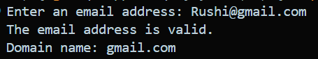
// Write a C++ program that takes a string as an input and check whether the string is palindrome or
// not ?
// ● A palindrome is a word, phrase, number, or sequence of characters that reads the same
// backward as forward.
// ● Example: madam , level.
// a) First convert the string in lowercase.
// b) Print “Palindrome” if true, otherwise print “Not a palindrome”.

#include <bits/stdc++.h>
using namespace std;

int main() {
string str;
cout << "Enter a string: ";
getline(cin, str);

string lower_str = str;
transform(lower_str.begin(), lower_str.end(), lower_str.begin(), ::tolower);

string reversed_str = lower_str;
reverse(reversed_str.begin(), reversed_str.end());

if (lower_str == reversed_str) {
cout << "The string is a palindrome." << endl;
} else {
cout << "The string is not a palindrome." << endl;
}

return 0;
}
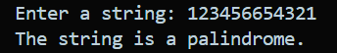

// Write a C++ program that takes two strings as input. Each string contains only unique characters
// (no character repeats within the same string).
// ● Your task is :
// A. Concatenate the two strings.
// B. While concatenating, remove any characters that are common in both strings.
// C. Print the modified concatenated string.
// ● Example:
// Input:
// str1 = "abcd"
// str2 = "cdef"
// Output : "abef"

#include <bits/stdc++.h>
using namespace std;

int main() {
string str1, str2;
cout << "Enter the first string: ";
cin >> str1;
cout << "Enter the second string: ";
cin >> str2;

string result = str1;
for (char c : str2) {
if (result.find(c) == string::npos) {
result += c;
}
}

cout << "Concatenated string without common characters: " << result << endl;

return 0;
}
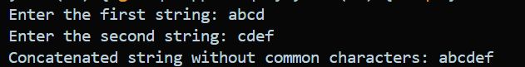

// Write a C++ program that asks the user to enter a sentence. Your program should:
// a) Count the total number of vowels (a, e, i, o, u) in the sentence.
// b) Count the total number of words in the sentence.
// c) Count the total number of uppercase letters and lowercase letters in the sentence.
// d) Replace all spaces with - (hyphen) and display the modified sentence

#include <bits/stdc++.h>
using namespace std;

int main(){
string str;
cout << "Enter a sentence: ";
getline(cin, str);
int vowel_count = 0;
int word_count = 1;
int uppercase_count = 0;
int lowercase_count = 0;
for (char c : str) {
if (c == 'a' || c == 'e' || c == 'i' || c == 'o' || c == 'u' || c == 'A' || c == 'E' || c == 'I' || c == 'O' || c == 'U') {
vowel_count++;
} else if (c == ' ') {
word_count++;
} else if (c >= 'A' && c <= 'Z') {
uppercase_count++;
} else if (c >= 'a' && c <= 'z') {
lowercase_count++;
}
}
cout << "Total vowels: " << vowel_count << endl;
cout << "Total words: " << word_count << endl;
cout << "Total uppercase letters: " << uppercase_count << endl;
cout << "Total lowercase letters: " << lowercase_count << endl;

// Replace spaces with hyphens
replace(str.begin(), str.end(), ' ', '-');
cout << "Modified sentence: " << str << endl;

return 0;
}
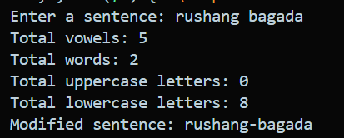
// Write a C++ program to check if an entered password is valid.
// ● Minimum 8 characters.
// ● At least 1 uppercase letter.
// ● At least 1 lowercase letter.
// ● At least 1 digit.
// ● At least 1 special character (@, #, $, %, &, *).
// Output should say "Strong Password" or "Weak Password" accordingly

#include <bits/stdc++.h>
using namespace std;

int main() {
string password;
cout << "Enter a password: ";
getline(cin, password);

bool hasUpper = false, hasLower = false, hasDigit = false, hasSpecial = false;
string specialChars = "@#$%&*";

for(char c : password) {
if(isupper(c)) hasUpper = true;
else if(islower(c)) hasLower = true;
else if(isdigit(c)) hasDigit = true;
else if(specialChars.find(c) != string::npos) hasSpecial = true;
}

if(password.length() >= 8 && hasUpper && hasLower && hasDigit && hasSpecial) {
cout << "Strong Password" << endl;
} else {
cout << "Weak Password" << endl;
}

return 0;
}
